**Steps to use printf in the Nucleo STM32F411RE**

When you will ready to load the program and debug, first you most do right click in the proyect you want to test, go to “Debug As” then, if is the first time debugging the proyect, select “STM32 C/C++ Application”

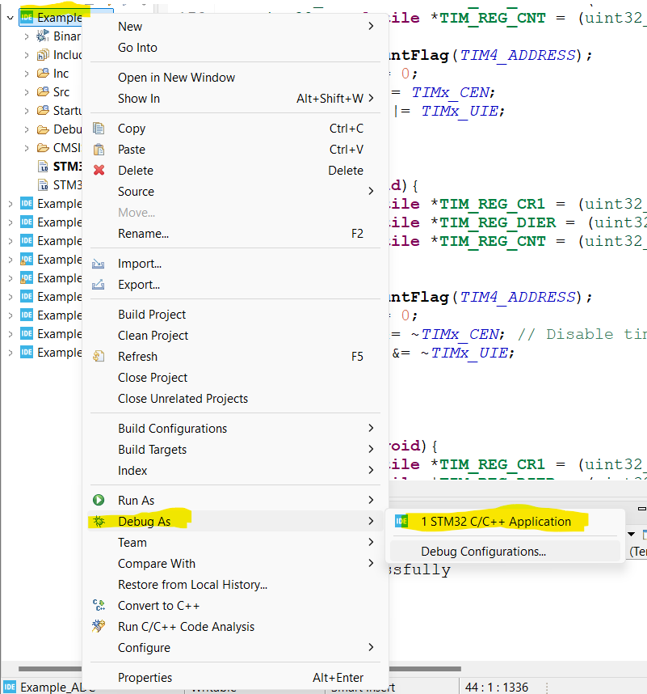

If is not the first time you debug, then select “Debug Configurations”

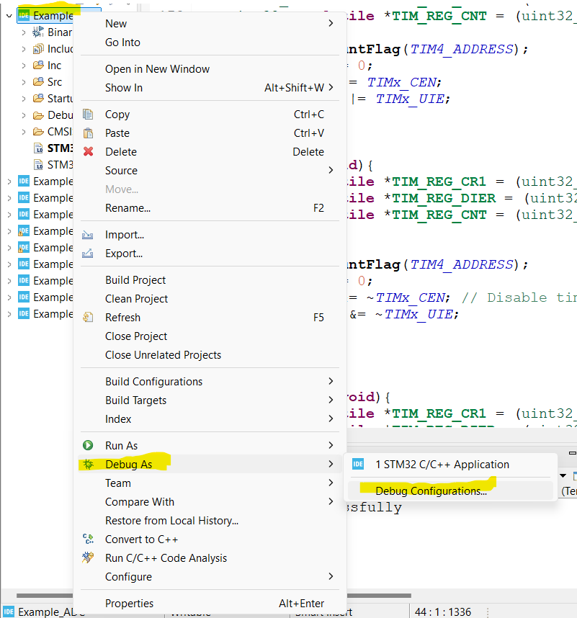

Then go to the option Debugger and enable the serial wire viewer (SWV), then press “Apply” and finally “Debug” or “OK”

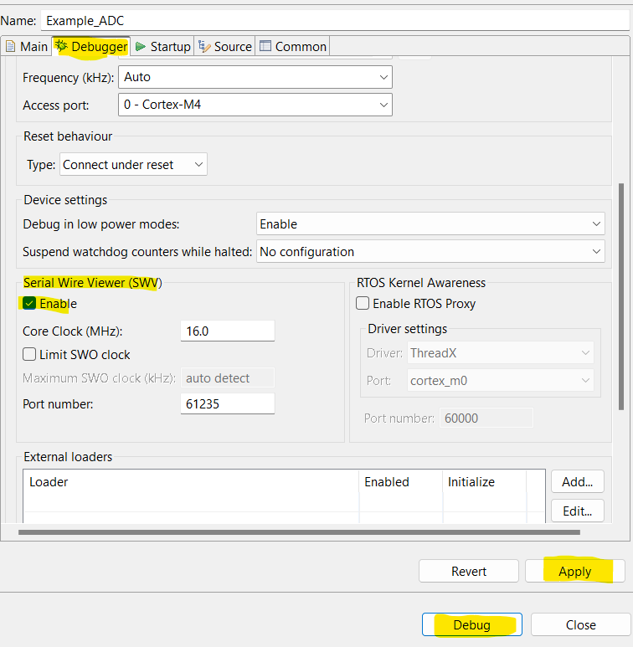

Then the Debbuger view will start. To be able to see the printf in the console you must do the followings steps.

Before you start to debugging, in the “Window” tab, go to “show view” then “SWV” and finally, press “SWV ITM Data Console”

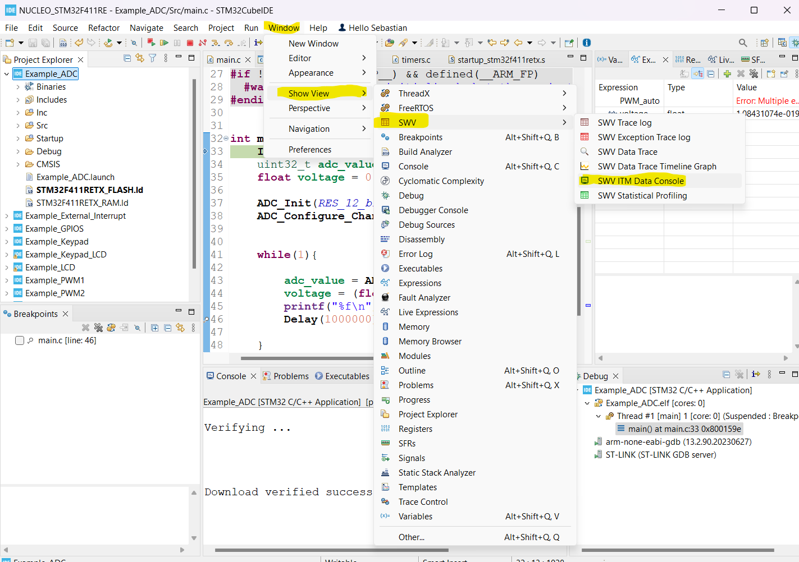

It will show another tap in calls “SWV ITM Data Console”, then you should prees the tools icon calls “configure trace”

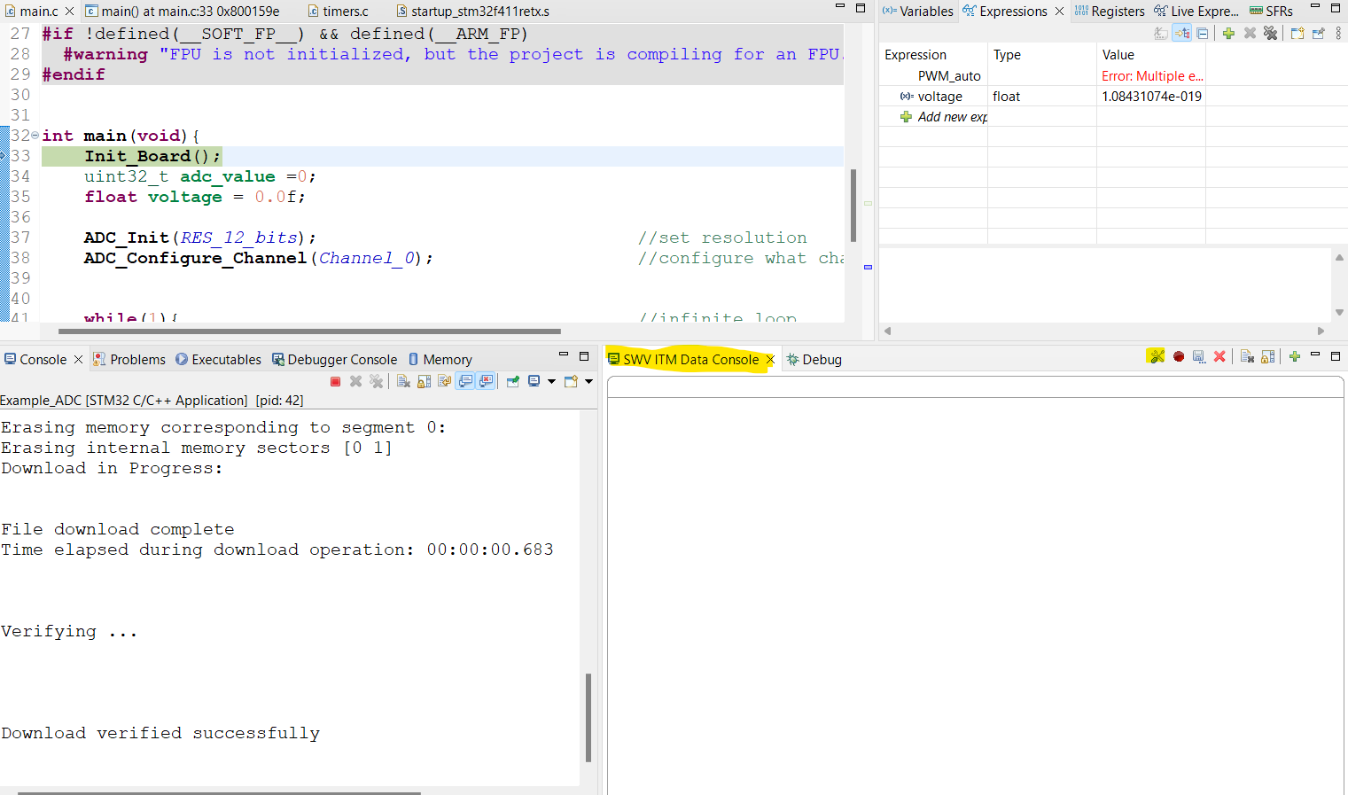

Athother window will open. Select the Port 0 and then press “Ok”

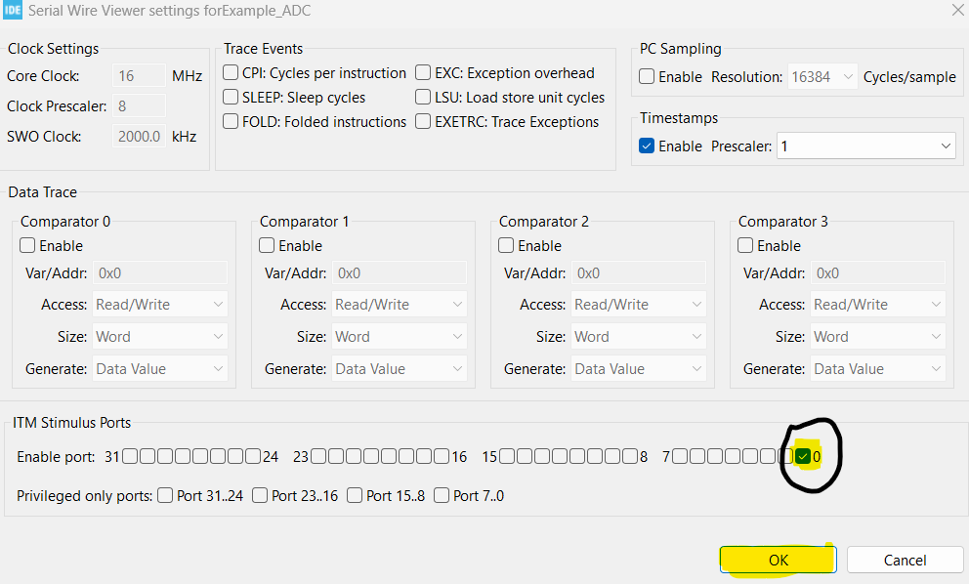

Finally press the icon with the Red circle with the name “Start trace” this will allows to see the information from the printf.

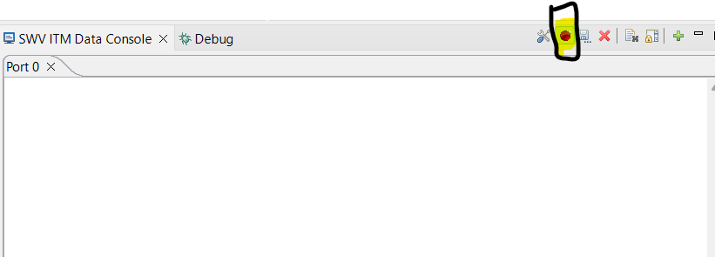

With this, the prints will be displayed in this console

